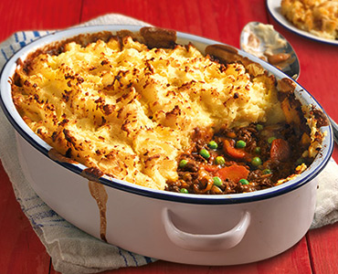Cottage Pie:

# Ingredients:

* 500g of Minced Meat
* 1 Diced onion
* Plain flour
* 250g Petite pois
* 2 *Large* carrots
* 1 Beef or vegetable stock cube
* Beef gravy ~ 1 pint
* A little oil to cook the minced meat in
* Tomato ketchup
* 8 Large/12 medium potatoes
* Butter

# Method:

With this recipe you have two options. You can make this cottage pie to eat on the day or premake for a few days’ time or, as I like to do, portion off the mixture for the base and freeze for a low effort mid- week meal. You can freeze fully made with the mash on top but I personally think it tastes best with the mash freshly made.

1. If you're not going to be freezing the base mixture, you will need to peel and chop the potatoes now and get them cooking until soft and fluffy whilst you follow the rest of the instructions. Otherwise, skip to the next step.
2. Cook the minced meat in a large frying pan on medium gas with a little oil for approximately 15 minutes until almost cooked through.
3. Add diced onion and cook for another 5 mins until the onion has softened slightly and drain off as much fat as you can.
4. Add 3 or 4 table spoons of plain flour to soak up the rest, be careful not to completely dry out the mince with the flour.
5. Cook whilst stirring frequently for no more than 5 more minutes before adding the peas and diced carrot.
6. When the veg is partially cooked, make up roughly 1 pint of beef gravy following the instructions on the packet and add to the pan. Add a generous squirt of ketchup also, roughly 3 tbsp.
7. Stir to sufficiently mix all of the ingredients.
8. Simmer for 10 minutes then turn off the heat.

If you don't plan on freezing the base mixture in separate portions for a later date then here is what you need to do next:

1. Drain your cooked potatoes and add a generous nob of butter before mashing them.
2. Spread the base mix evenly over the bottom of an oven safe dish so that the dish if roughly half full.
3. Then, gently add the mashed potatoes on top and spread out, creating a second layer on top which fills up the other half of the dish. I find that using a fork works best and gives a nice crispy finish when cooked.
4. Place on the centre shelf of the oven for 40 minutes at 180˚C until the mash is golden brown and slightly crispy.
5. Check with a knife that the pie is hot all the way through then leave to cool before serving.
6. Enjoy!

If you are freezing the base mix then leave to cool for 10 minutes then potion into freezer safe bags or boxes. Once cold, you can place them in the freezer to use another day (they last for up to 3 months).

Using your frozen base mix:

1. When you come to use the base mix, defrost in your oven dish.
2. Cook and mash the potatoes with a generous nob of butter before gently spreading over the top of your base mixture using a fork.
3. Place on the centre shelf of the oven for 40 minutes at 180˚C until the mash is golden brown and slightly crispy.
4. Check with a knife that the pie is hot all the way through then leave to cool before serving.
5. Enjoy!